|  |
| --- |
| Photo displaying partial image of two pie charts on a canvas-textured page |
| Operator and expression generator user manual  First Edition |
| |  |  |  | | --- | --- | --- | | Molinge L. Jr | 10/14/17 | [Course title] | |

**CONTENTS**

1. Historical Background ……………………………………………………………...
2. Description of parts of the graphical user interface ………………………………...

2.1. Operator palette ………………………………………………………………...

2.2. Application of functions palette ………………………………………………...

2.3. Intermediate results palette ……………………………………………………...

2.4. Menus …………………………………………………………………………...

1. Usage of software to generate desired outputs ……....................................................
2. Some tips on how to use software efficiently …………………………………………

**Chapter 1**

**Historical background**

The author, Molinge Lyonga Jr, started to work on this software in 2017. This software was the Molinge’s first real software, given to him by the University of Buea as a final year project for his Bachelor in Science in Computer Science. Through a few months (about 4) of rigorous dedication to this project, he came out the first release of the “Operator and Expression Generator” which was very productive and instrumental, though in this release all features intended by the Molinge has not all fully been integrated into the software given the time constraints that he worked on. Probably in the next release a huge advancement would have been done.

Before we go on describing the components of the user interface. Let’s first get an overview of the system which is given below.

**Description of software**

This system [Operator and Expression Generator] provides a graphical user interface and a text user interface [for usage of some back-end functions] that allows users to carryout computations [by applying functions and/or constants together] to produce expressions as results. These results can also be in the intermediate[incomplete] form which can still be manipulated to produce the desire result or expression. Functions and Constants are provided or displayed on a grid table, where options for manipulating the grid’s display and structure are also provided along with those for creating functions/constants. Options for choosing desired operators are given on the interface under various categories. An operator chosen can be applied on arguments [functions/constants on grid] by performing some actions [like drag-and-drop, right-clicking]. There’s also a grid provided for intermediate results for further manipulations. The expression generated can be outputted into a file in a chosen format [like reverse polish, prefix, or infix notations] by means of a back-end function provided by the system through the Text user interface. The resulting expressions are displayed on a cell [on the grid] found at the intersection of the operator’s arguments [functions/constants and functions/constants on the grid]. Repeated application of two arguments with different operators result in different expressions saved on the arguments intersection cell [cell is of 2D format] and provide an option for viewing this cell as a 2D format. The systems also provide means [file menu] of saving and loading the grid on to our application from a file in a unique format.

**Chapter 2**

**Description of parts of the user interface**

This chapter describes the main parts of the GUI and their uses. The diagram of the GUI is shown below.

D

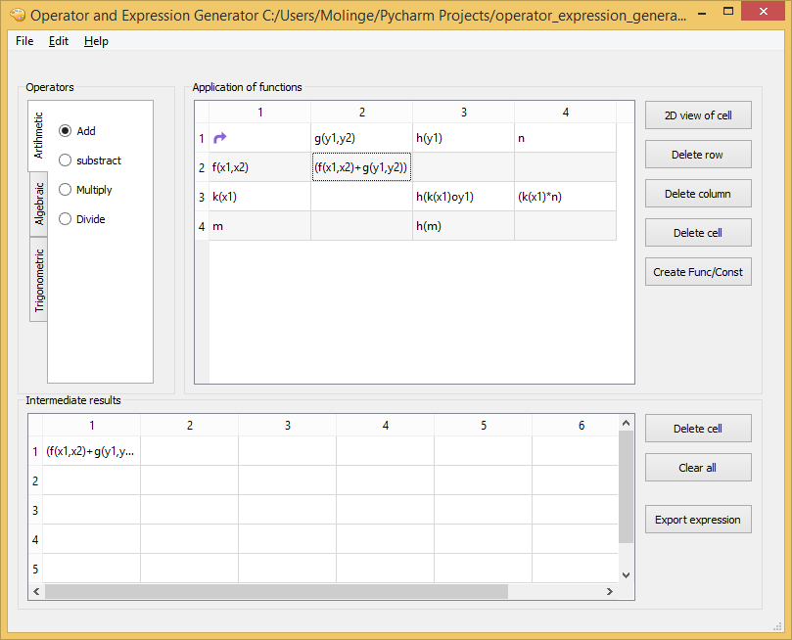

B

A

C

Figure 1: Diagram of the GUI

From the diagram above, the main sections have been indicated by arrows and the explanation of each section is given as follows:

**2.1 Operator Palette (A)**

This palette contains all available operators to use. These operators are separated in tabs as shown in figure 1, each of these tabs represents an operator category (for example Arithmetic, Algebraic) in which each contains a list of operator instances (for example Add, Subtract). Only a single operator can be chosen at a time from all available operators.

The Add operator is chosen as the default operator.

**2.2 Application of functions palette (B)**

This palette is responsible for carrying out operations on functions and constants. It is made up of a grid as shown in figure 1. The buttons responsible for carrying and manipulating the grid are outlined at the right hand side of the palette.

Before explaining what each button does let’s talk about the available set of events that can be established just within the grid. They are as follows:

* Functions/ constants can be dragged from the Vertical functions at the first column onto those at the Horizontal at the first row. Once these happens an operation is carried out on these two functions based on the operator chosen.
* Functions/constants can be dragged also into the Intermediate result palette shown on figure 1 above at arrow C.

The events (outcomes) that occurs by clicking these buttons are explained below:

* **2D view of cell button:** What displays on the cells found at the functions/constants intersection (that is where the two function meet) is the top element of the cell on the grid Once this button is clicked, a dialog pops up if a cell (excluding the first row and first column) has been chosen. This dialog now displays a 2D view of the cell revealing the other components which seemed to be hidden at first sight.
* **Delete row:** This deletes a selected row on the grid.
* **Delete column:** This deletes a selected column on the grid.
* **Delete cell:** This deletes a selected cell on the grid.
* **Create Func/Const:** This allows the user to create his/her own function.

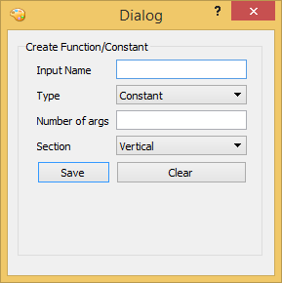 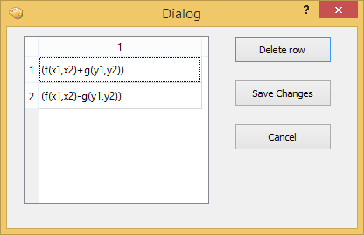

Figure 2: After clicking the Figure 3: After clicking the “2D view of CreateFunc/Const button cell” button once cell 2,2 is selected

**2.3 Intermediate results palette (C)**

This palette is responsible for displaying intermediate results generated from the Application of functions palette’s grid. The results are displayed on this palette’s grid [labelled C on figure 1], where these results can be further manipulated to produce further intermediate results until the desired final results have been obtained based on the user’s choice of outcome. Functions can be dragged into the grid from the Application of functions palette for further manipulations. At the right hand-side of its grid are buttons which perform some operations on the grid which we will see below.

These buttons are as follows:

* Delete cell: This deletes the contents of a cell that has been chosen on the grid
* Clear All: This deletes all data on the grid
* Export expression: This pop up a dialog that collects user’s information, which uses that information to export the expression in the desired format of the user. This is displayed in the figure below.

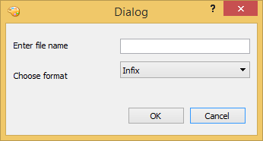

Figure 4: After clicking the Export

expression button

**2.4 The menus (D)**

Now at the menus tab lies three different menus (File, Edit and Help). These menus provide a list of menu options which provide a variety of functions as we shall see below.

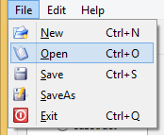 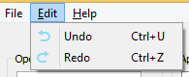 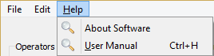

Figure 5: File menu Figure 6: Edit menu Figure 7: Help menu

The **File menu** is responsible for performing actions on an external file. These options are:

* New: This creates an empty workspace
* Open: This opens an existing file
* Save: This saves a file
* SaveAs: This saves a file with a different name
* Exit: This exits the system

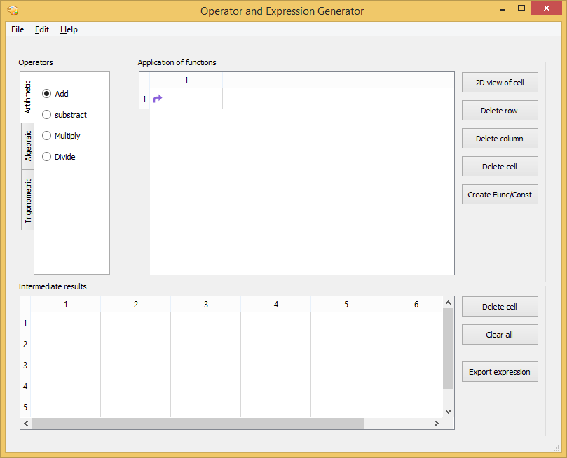 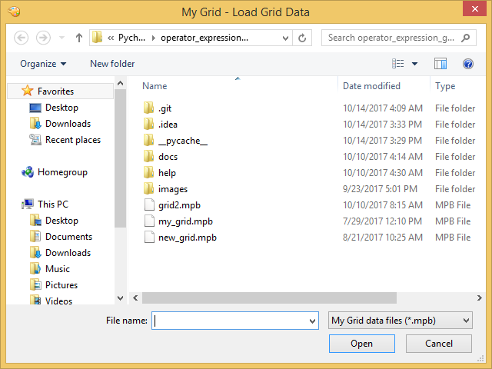

Figure 3: After clicking the “New” Figure 4: After clicking the “Open” File menu File menu option

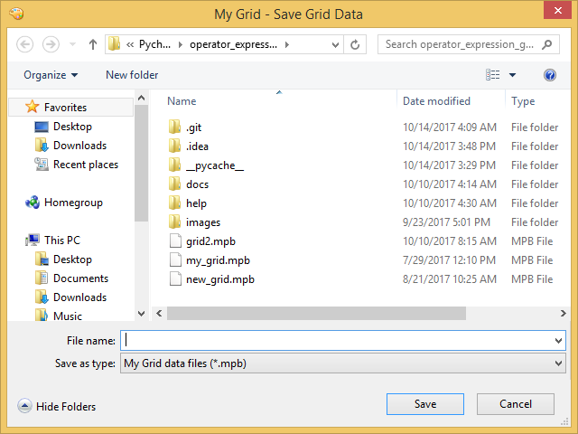 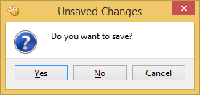

Figure 5: After clicking the SaveAs file menu Figure 6: After clicking the Exit file menu option when there’re still unsaved changes

The **Edit menu** is responsible for editing. It provides two options which are:

* Undo: It reverts a change made
* Redo: It brings back a change that was discarded

The **Help menu** is responsible for providing helpful tips and information about the GUI. These options are:

* About Software: This provides us with a tip about the software
* User Manual: This displays our user manual

**Chapter 3**

**Usage of software to generate desired outputs**

This chapter explained how to use this software to generate desired outputs based on user’s preferences.